
Caleb Michael Sarvis
Copywriter • Author • Editor

cmsarvis@ymail.com
904-307-5523

Mission Statement
I’m a creative workhorse who is looking for a long-term—and perhaps, forever—home in which to flex my brain waves and grow into the writer I know I can be.

Work Experience  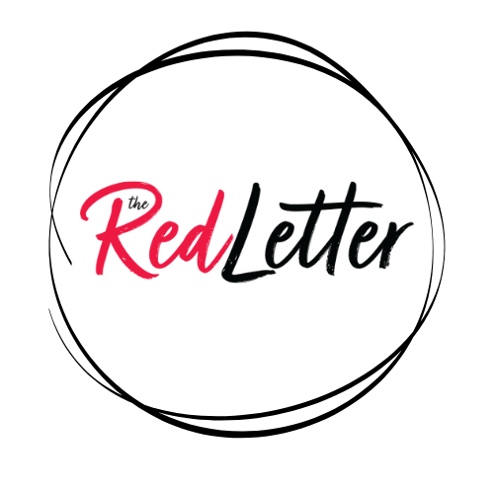   | Tara Palmeri’s The Red Letter (Mar 2025 – Present)  Freelance Copyeditor  - Proofread and copyedit political-insider Tara Palmeri’s newsletter The Red Letter  Majority Strategies (Apr 2018 – Present)  Lead Copywriter  - Lead the acquisition and onboarding of new writers  - Cultivate new training material as needed  - Manage creative hiccups, errors, or other mistakes by the writing team  - Act as the liaison between writers and senior leadership such as the COO and CEO  Senior Copywriter  - Edited, sharpened, and proofread the work of fellow creative copywriters.  - Curated weekly advertising newsletter: Creative Scoop.  - Assisted in the training of new employees.  - Led weekly creative workshops critiquing and improving each other’s work.  - Worked with more highly-esteemed clients such as the RNC and U.S. Congressman.  Creative Copywriter  - Wrote creative and persuasive copy for political and advocacy campaigns. Work included printed mailers, digital flights, mobile flights, and websites. Wrote blogs for internal use as well.  - Provided occasional voiceover work for videos.

Education    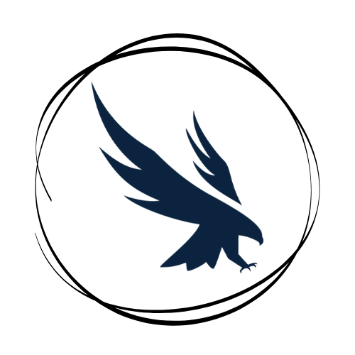 | University of Tampa (Jan 2015 – Jan 2017)  MFA in Creative Writing – Fiction  University of North Florida (Aug 2010 – Apr 2012)  BA in English Literature  Minor in Creative Writing
Publications | Books  - Dead Aquarium or (i don’t have the stamina for that kind of faith) (Mastodon Publishing 2019) - Fiction  - 15 Views of Jacksonville (Bridge Eight 2018) – Fiction Anthology, Editor

